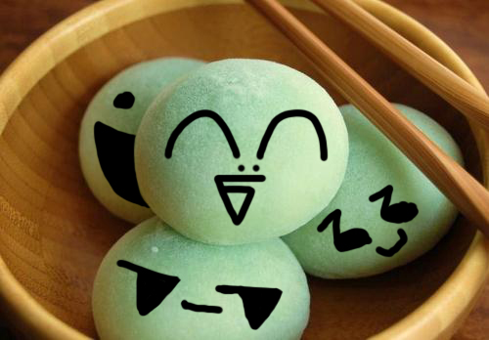

It’s Mochitsuki Time!

Hello Eden Family! It is that time of year again. The annual Mochitsuki will be held December 10, 2016.

Mochi or rice cake is essential to the Oshogatsu or New Year's celebration. The pounding of steamed mochigome or sweet glutinous rice to make mochi is called Mochitsuki. In earlier times, both in Japan and within the Japanese-American community, friends and family would gather together to pound the New Year's mochi. Mochitsuki is an all day event, which requires many hands, long hours, and physical labor, but it is also a time of fellowship and socializing.

The price of mochi this year will be $4.00 per pound, with a minimum order of 2 pounds. Mochi will be packaged in 2 pound and 3 pound containers. Because we will be producing approximately 900 pounds of mochi this year, we are able to fulfill orders up to 10 pounds maximum per family. However, we will place any additional mochi requests on our waiting list. This means that when our pre-orders have been filled, if there is any extra mochi at the end of the day, you will receive a call that you may buy more.

For reference, we can look up in our records how many pounds you purchased in the past – just call or email! Orders may be picked up at the Eden Japanese Community Center between 3:00pm – 6:00pm on Saturday, December 10th. If you’re unable to pick up the mochi on the day of the mochitsuki, the mochi will be frozen and arrangements can be made to pick up the mochi at a later date. Those with special needs can call Aaron Corley at (562) 787-2636 to arrange for possible delivery, though delivery cannot be guaranteed for December 10th.

To place an order by email, contact us at aaronishere@yahoo.com. To place an order by phone, please contact Aaron Corley at (562) 787-2636. Or mail this form by December 6th to:

Aaron Corley
29717 Holiday Street
Hayward, CA 94544

EDEN Mochi Order Form
Saturday, December 10, 2016

Name:
Phone Number:
E-mail address:

We would like to order pounds of mochi @ $4.00/lb.
Please place pounds of mochi on the waiting list.
Total order pounds of mochi, if available.

To Order Mochi:
Please submit orders by email to: aaronishere@yahoo.com
by phone, call Aaron Corley at (562) 787-2636
or mail your requests to: Aaron Corley, 29717 Holiday Street, Hayward, CA 94544

Payment will be collected at time of pick-up.

** Orders due December 6th, 2016 **

